PRESS RELEASE
THE ULTIMATE GAME ROOM COMES ALIVE FOR A WEEKEND OF FUN AND FREE PLAY!
The Houston Area Arcade Group (HAAG) is holding their 15th Annual Arcade Expo on November 11th & 12th at the Houston Northwest Crowne Plaza at Pinemont and Hwy 290.
There will be over 200 classic and current coin-op pinball machines, video arcade games, penny arcades, and console video games ready for attendees to play on free play or buy them for their home. There will be Tournaments, events, music and workshops to keep the young and young at heart entertained.
- Pinball, Video Arcade, Console, tournaments all day Friday and Saturday!
- The latest 2016 pinballs: Ghost Busters, Dominos Pizza, P3 Pinball system, the Hobbit, and Batman 66!!
- Guest Classic Pinball Artist & Art Director Paul Faris with twenty years of experience working with Pinball Art will be on hand. A few of his games include Evel Knievel, Eight Ball, PlayboyParagon, Xenon, and Centaur.
- Guest Jeremy Packer—aka Zombie Yeti— makes world-class art for Harley Davidson, 20th Century Fox, Wu-Tang Clan and Stern Pinball. His work on the new Ghost Busters Pinball is truly epic
- Speakers will include Dan Ferguson (Lone Star Pinball Museum) on the History of Pinball, Ken Graham former Williams Programmer, There will be Basic electronics, Pinball, and Arcade repair clinics to help attendee’s to get their machine’s back up and running or just to do basic maintenance.
- Guest Dominos Pinball Panel! The creative guys from Spooky pinball and Adam Gacek from Dominos corporate will talk about their projects & there will be free pizza during the seminar!
- Midnight showing of the film Showing of Lars the Emo Kid Movie with Joe Grisaffi
- Bands and Music return this year, It’s a NERD ROCK TAKEOVER. The Consortium of Genius are an industrial-strength powerhouse featuring up to eight cerebral miscreants who jolt their audience into staggering submission. The resulting evil brainchild is part musical showcase, part sketch comedy, and all hi-tech magic!
- Atari Age might be returning to the mix this year! If not we will have plenty more. This includes Atari 2600, 5200, 7800, ColecoVision, Vectrex, Intellivision, Sega, NES, Xbox 360 and other modern & classic consoles.
- Cosplay Costume contest to Qualify for the contest you can be ANY character from any Coin-Op Arcade game or Pinball This includes themed pinball’s and arcade games!
- All Weekend Star Wars and other Costume Characters will be at the show come and meet your favorite member of the Empire & the Rebel Alliance!!!
- Free! Parking Lot Swap Meet, where you can buy and sell your project games and cool stuff, Door prizes called out every 30 mins during the show, Try your luck at a game raffle to win a full stand up arcade.
- Pinball & Arcade games for Sale for your home or business. We will have tons of arcade and pinball parts, Manuals and memorabilia. Even great general memorabilia.
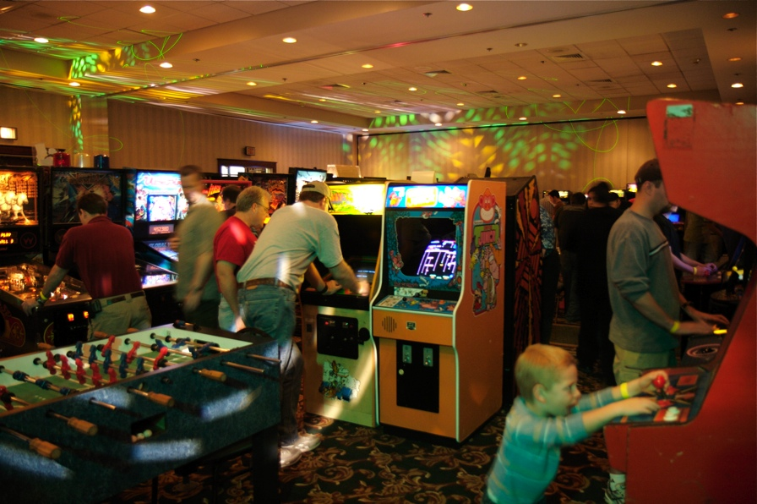
What: 2016 Houston Arcade Expo
Web Site: www.arcadecenter.com
Dates: November 11^{h} & 12th , 2016

Hours:
Nov 11th: Noon until 2am
Nov 12th: Swap Meet 8am to 11am
Nov 12th: 10am until 2am

Location:
Houston Northwest Crowne Plaza
12801 NORTHWEST FREEWAY
HOUSTON, TX 77040 UNITED STATES

Tickets:
Admission is $40 for a weekend pass or $30 for a single day, which gets you access to over 200 arcade, console and pinball machines all set to free play!

More info: 713-375-1801 (Keith Christensen) or www.arcadecenter.com

